URBANDALE ELEMENTARY COUNSELING PROGRAM

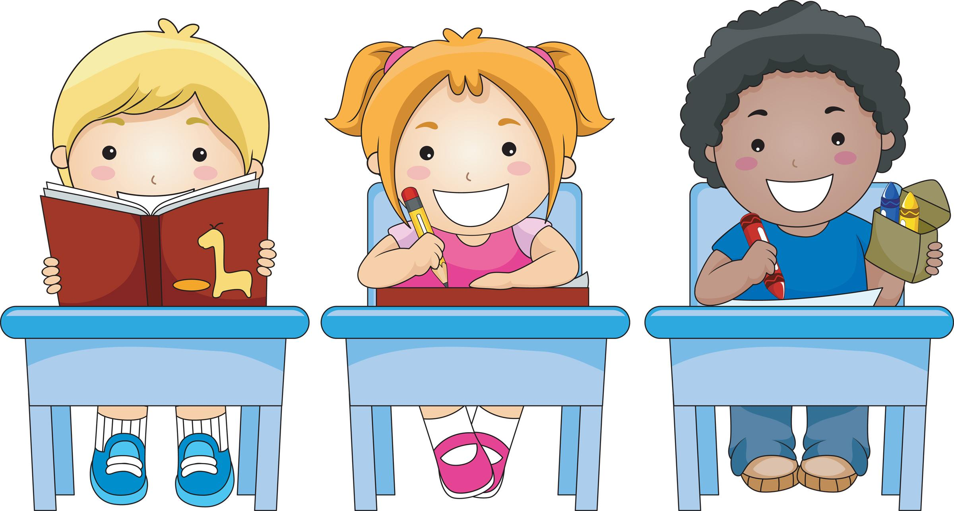

Kindergarten Expectations for Skills for Learning

Students will know skills that help them learn (Paying attention, listening, asking questions, and self-encouragement).

What you can do at home to help your child

Focus Activities
Listening skills | ♦ Practice sitting still, using eye contact when listening.  ♦ Play “Simon Says” to practice following directions.  ♦ Take your child to the library for storytime to practice listening.  ♦ Play “21 questions” or the hedbanz game to encourage relevant questioning.
Contact your Elementary School Counselor, Danielle Murphy, for more ideas

