URBANDALE ELEMENTARY COUNSELING PROGRAM

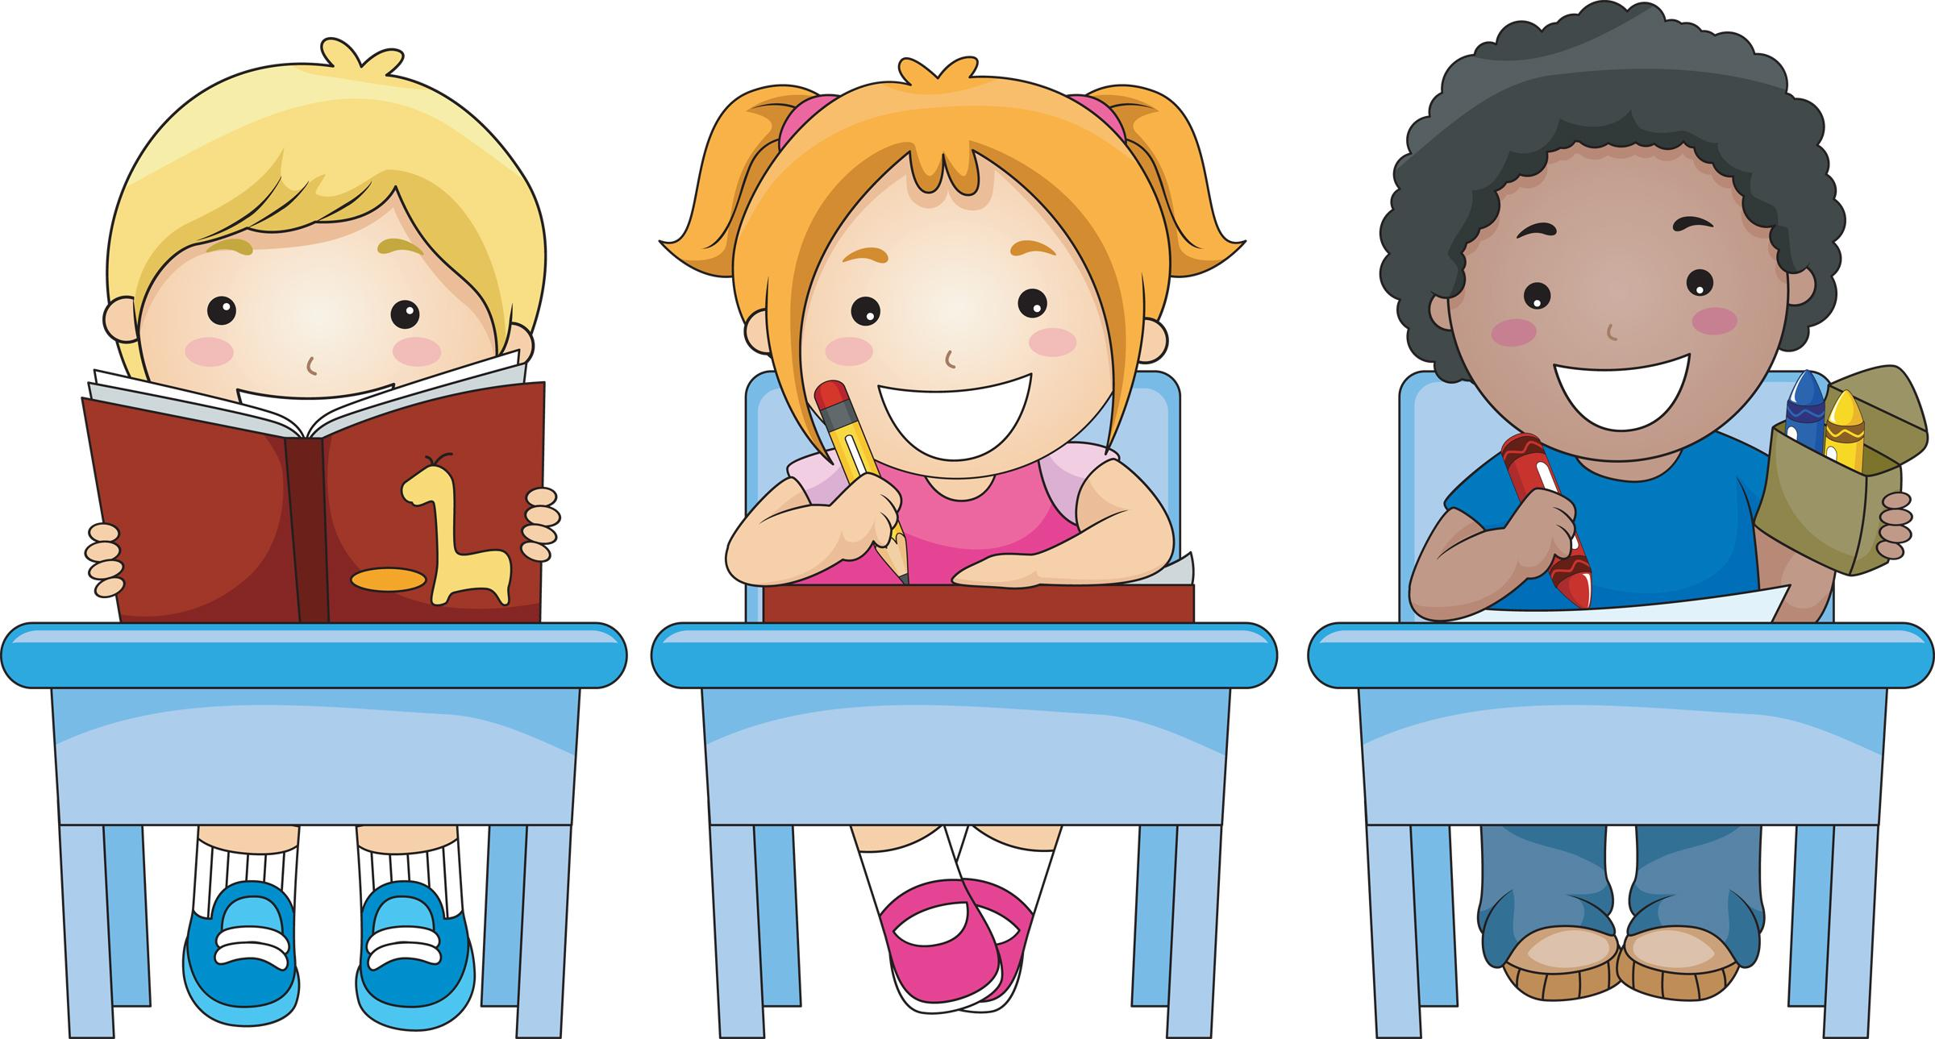

4th Grade Expectations for Skills for Learning

Students will know how to organize their time to manage their day.
Students will know how to set a SMART goal; specific, measurable, attainable, relevant, time-bound.

What you can do at home to help your child

Things That Influence Success | ♦ Share how effort, luck, ability, or others played a role in a successful situation  ♦ Encourage your child to keep a calendar of personal activities.  ♦ Encourage your child to do first things first. (Homework before play, etc.)  ♦ Tell your child goals you set and what you did to reach them. Encourage them to set goals and discuss a plan for reaching them.
Learning Styles - Everyone learns in different ways | ♦ Ask “How do you learn best? What are your strengths in learning?”  ♦ Share what your areas of strength are.
Homework Tips | ♦ Set up a quiet place, away from distractions, for homework  ♦ Agree on time for homework each day  ♦ Have materials available (paper, pencils, etc.)  ♦ Talk about different ways to study for a test

Contact your Elementary School Counselor for more ideas.

