URBANDALE ELEMENTARY COUNSELING PROGRAM

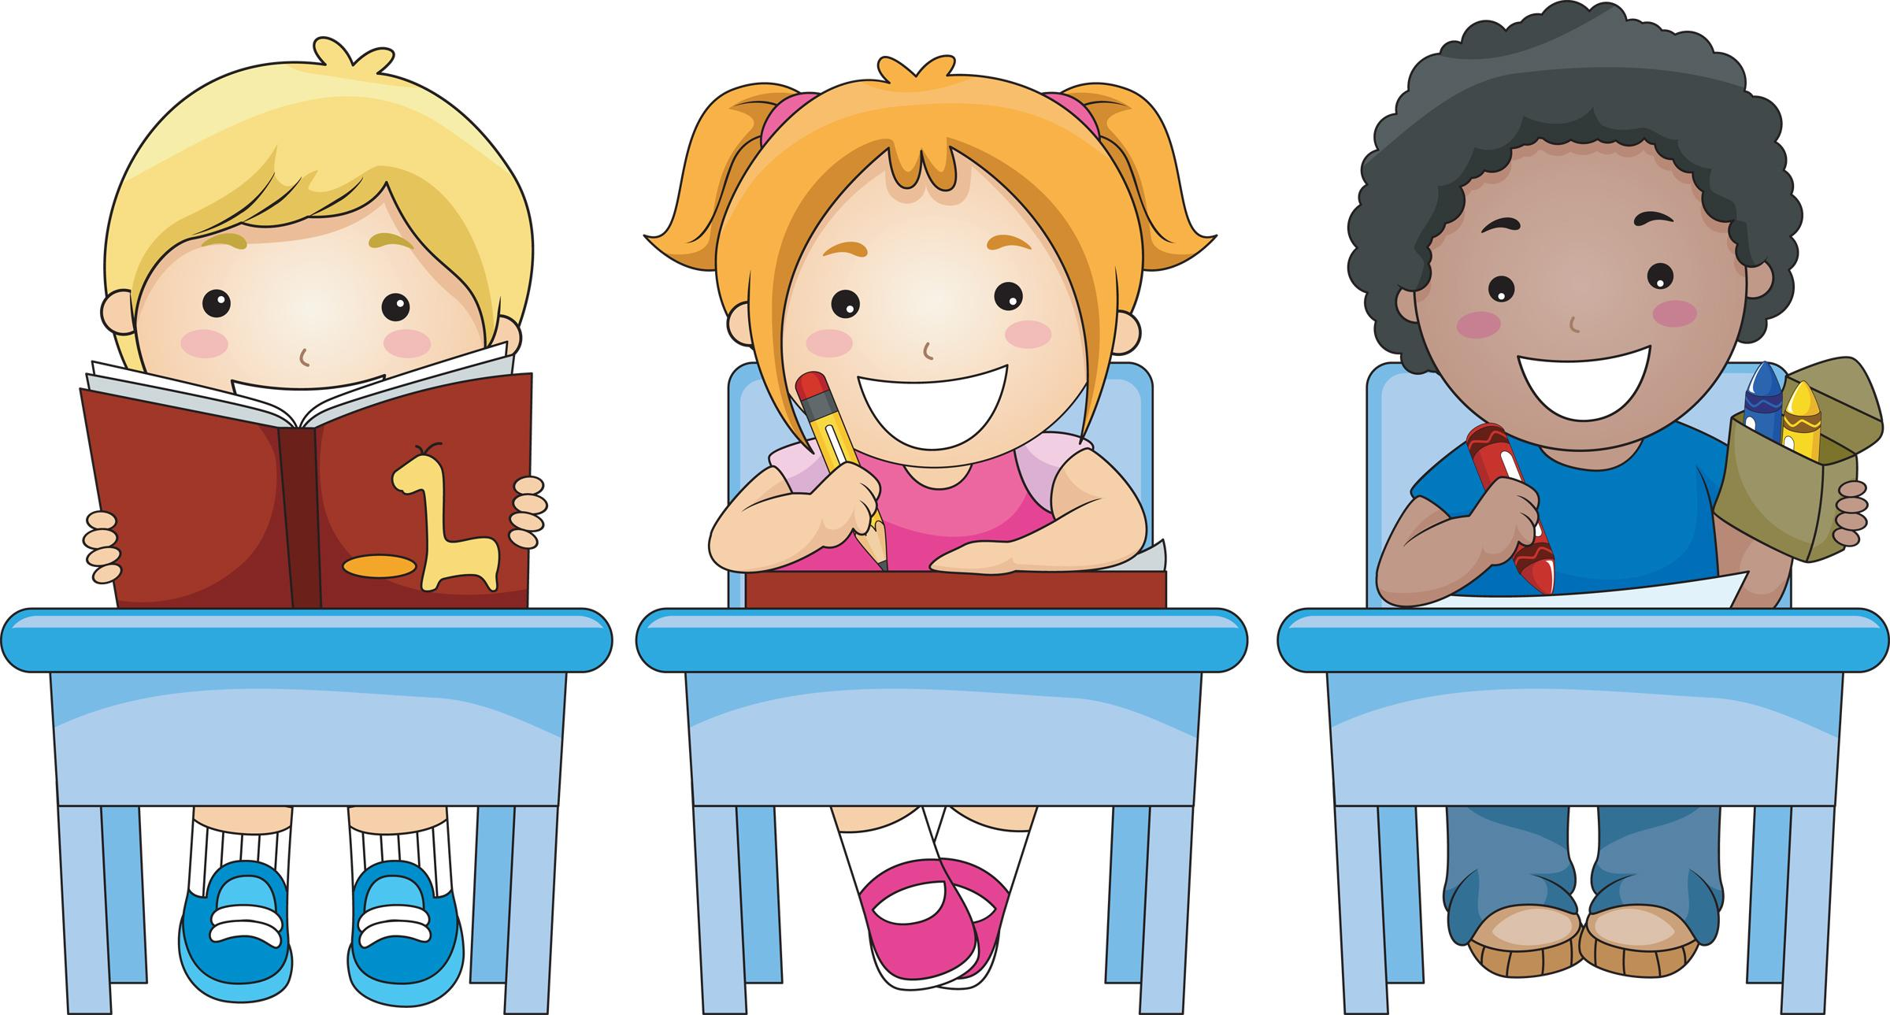

3rd Grade Expectations for Skills for Learning
Students will know what a priority is; doing the most important things first.
Students will know the importance of setting a goal that is measureable.
Students will know how to organize their materials to learn. (Planner, backpack, desk or locker--if applicable)

What you can do at home to help your child

Develop a Routine | ♦ Set routines for homework, bedtime, exercise and good hygiene.
Talk and Think Positively | ♦ Develop a family cheer rap song, etc. using encouraging words.
Don’t Get Stuck | ♦ Divide chores and activities into smaller, easy to manage portions.
Practice to Make Progress | ♦ Make a practice chart to track progress (homework, chores, sports, music, etc.)  ♦ Help your child set short-term goals at home and offer encouragement to reach those goals.
Organization | ♦ Check your child’s backpack and planner daily until it becomes a habit.

Contact your Elementary School Counselor for more ideas.

