URBANDALE ELEMENTARY COUNSELING PROGRAM

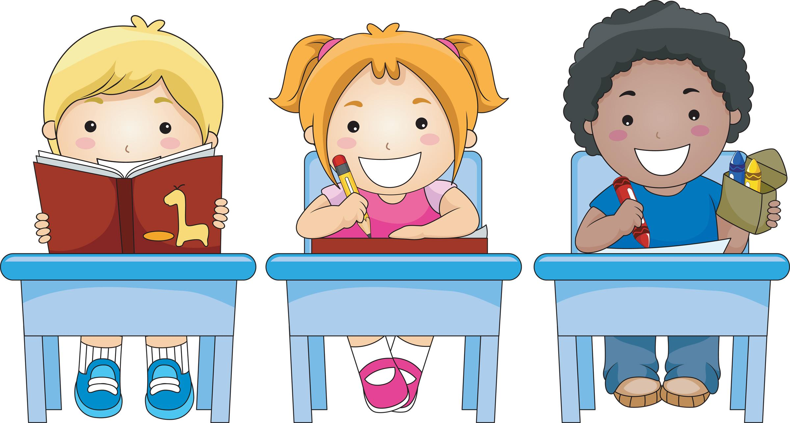

2nd Grade Expectations for Skills for Learning

Students will know that mistakes are a part of learning. (Keep trying when things are hard.)
Students will know how to follow directions; listen to the complete directions before beginning work, listen to understand what is being said, repeat to self, ask questions if needed, begin to work.

What you can do at home to help your child

Organization | ♦ Practice by cleaning and organizing dresser drawers, kitchen cabinets, etc.  ♦ Sort toys into groups.  ♦ Use a timer to encourage your child to begin and complete tasks promptly.
Positive Self- Talk and Persistence | ♦ Invite your child to make a thought bubble and write several positive things to think for times when he/she is frustrated.  ♦ Students need the opportunity to know mistakes are okay and persistence is important. Encourage them to keep trying and resist the urge to fix it for them.
Contact your Elementary School Counselor for more ideas.

