URBANDALE ELEMENTARY COUNSELING PROGRAM

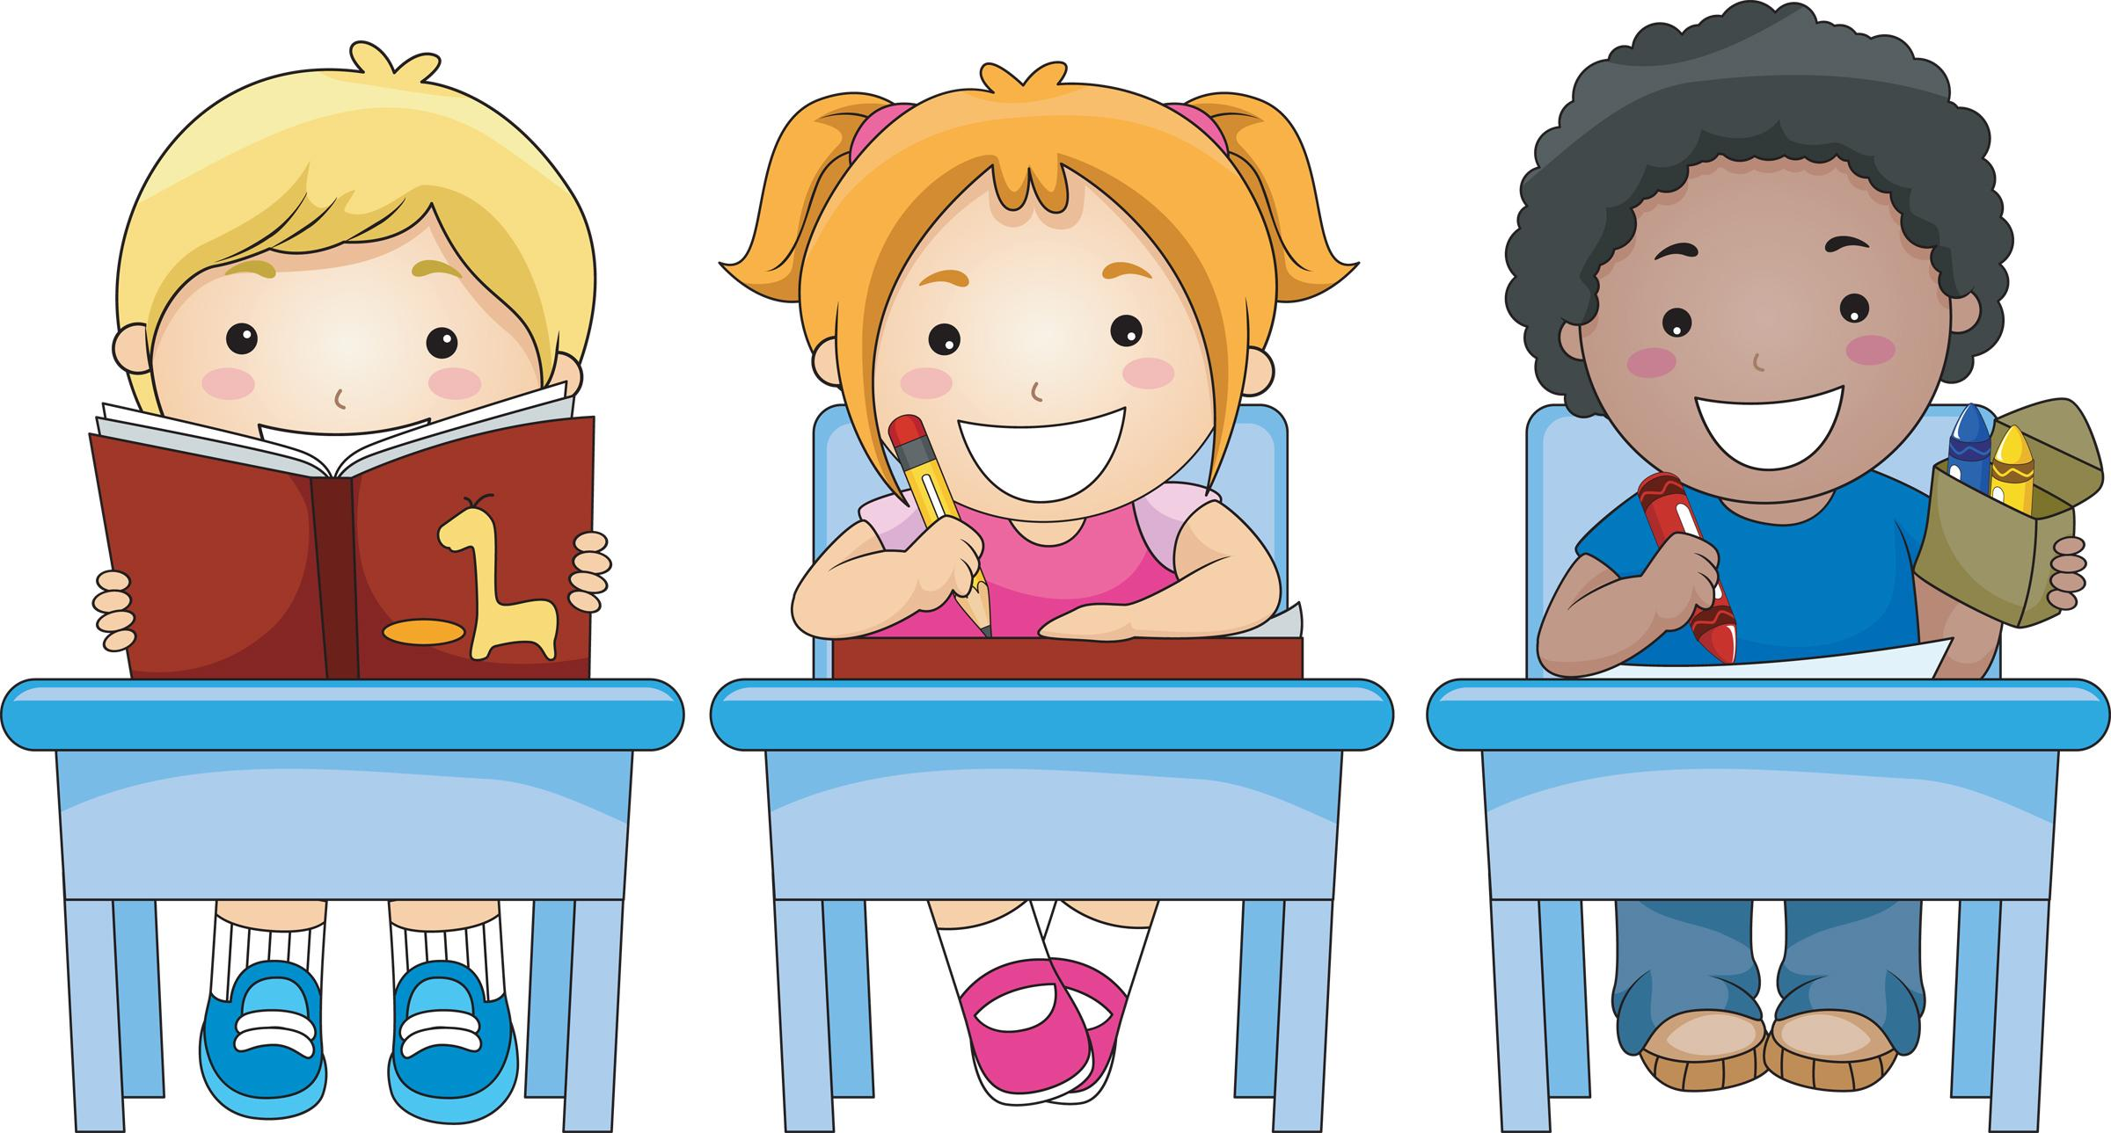

1st Grade Expectations for Skills for Learning
Students will know skills needed to pay attention; eye contact, think about what is being said, be quiet, sit still.

What you can do at home to help your child

Focus Activities
Listening Skills | ♦ Practice sitting still, using eye contact when listening.  ♦ Play “Simon Says” to practice following directions.  ♦ Take your child to the library for storytime to practice listening.

Contact your Elementary School Counselor for more ideas.

