URBANDALE ELEMENTARY COUNSELING PROGRAM

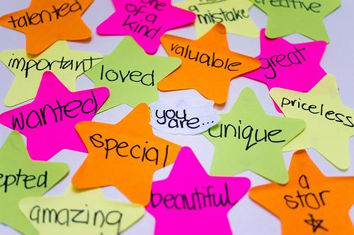

3rd Grade Expectations for Intrapersonal Skills Development

Students will know the roles they play in their lives improve their self-esteem. (daughter/son, student, friend, teammate)
Students will know setting personal goals can improve self-esteem.

What you can do at home to help your child

• Have your child list five personal strengths.
• Having responsibilities increases a sense of self-worth. Give your child opportunities to show responsibility.
• Encourage positive self-talk (I can do hard work, I have friends who care about me, I am kind, I am special).
• Setting goals and working towards achieving them will positively affect our self-esteem.
- Ask your child, “What is something you’d like to improve or get better at?”
- Help your child set a goal and list steps to follow to help reach the goal. Write it down and post it where it can be seen everyday.
- Check with your child daily to help monitor progress toward the goal. If your child is not making progress, discuss roadblocks that may be in the way and how they can work through them.
- Encourage your child to use positive self-talk and continue working toward the goal.

Contact your Elementary School Counselor for more ideas

