URBANDALE ELEMENTARY COUNSELING PROGRAM

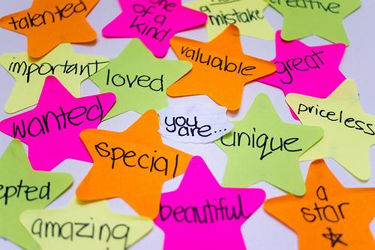

2nd Grade Expectations for Intrapersonal Skills Development

Students will know how to protect their self-esteem (Doing, Thinking, Talking, Feeling tools).

What you can do at home to help your child

Self-Esteem Tools
Doing Tools - actions you take, things you do (walking away, hitting someone)
Thinking Tools - what you say in your head (turn negative self-talk to positive self-talk)
Talking Tools - what you say to others (letting others know how you feel)
Feeling Tools - expressing feelings honestly, when you understand your feelings you can choose more effective doing, thinking and talking tools

• Have your child list five personal strengths.
• Having responsibilities increases a sense of self-worth. Give your child opportunities to show responsibility.
• Encourage positive self-talk (I can do hard work, I have friends who care about me, I am kind, I am special).
• Ask your child, “Which self-esteem tool are you good at using?”
• Ask your child, “Which tool is difficult for you to use?”
• Ask children to give examples of a situation in which they chose actions that: a.) got them in trouble or b.) caused them to feel bad about themselves. Which self-esteem tool could you have used differently to have a better outcome?

Contact your Elementary School Counselor for more ideas

