URBANDALE ELEMENTARY COUNSELING PROGRAM

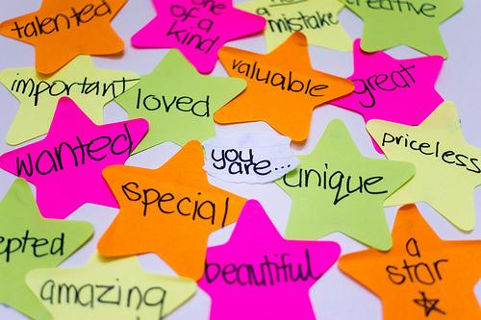

1st Grade Expectations for Learning About Intrapersonal Skills

Students will know what self esteem is.
Students will know who helps grow their self esteem.
Students will know some people can lower their self esteem.

What you can do at home to help your child

• Have your child list five personal strengths.
• Discuss with your child, “Who are people at home and school who make you feel good about yourself?”
• Ask your child, “What can you do when you are around someone who makes you feel badly about yourself?”
• Having responsibilities increases a sense of self-worth. Give your child opportunities to show responsibility.
• Encourage positive self-talk (I can do hard work, I have friends who care about me, I am kind, I am special).

Contact your Elementary School Counselor for more ideas

