URBANDALE ELEMENTARY COUNSELING PROGRAM
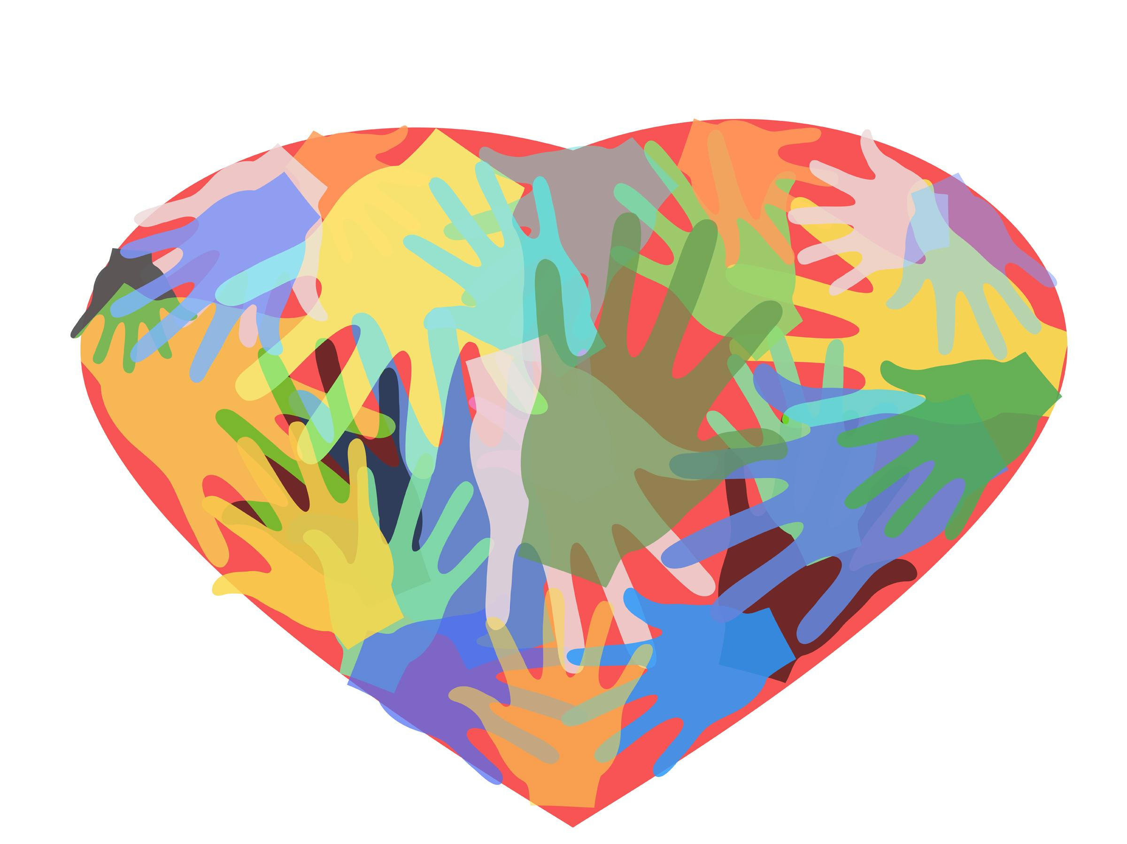
4th Grade Expectations for Learning About Ethical Behaviors

Students will know the people involved in the bullying triangle and why they might fit in those roles- BULLY (have been a target in the past, no friends, low self esteem), TARGET (timid, lacks confidence, seen as different, always alone), BYSTANDER (afraid they will be bullied too, don’t know what to do, go along with the bully or do nothing) UPSTANDER (confident, brave, empathetic, supportive)

What you can do at home to help your child

Definition of Bullying
Mean or hurtful behavior
Done on Purpose
Repeated over time
Must have an imbalance of power (target feels scared or uncomfortable)

• Ask your child, “Who are three friends who support you if you are having a problem?”
• Talk about problems your child can solve alone and problems where help is needed.
• Talk with your child about why someone might stand by and do nothing in a bullying situation.
“What are some things you could do to stand up for someone that you are brave enough to try?”
• When watching movies with your child, notice if characters are bystanders or upstanders.
• Ask your child to share some positive thoughts they have about themselves to help them feel confident and empowered.
• Have your child tell you different ways you can be an upstander for the target without saying a word to the bully. (help the target walk away, invite the target to sit with you, tell the target you are there for them and you understand how they feel)
• Ask your child, “Is there anything you can do or say to help the bully change his or her behavior?”

Contact your Elementary School Counselor for more ideas

