|  |  |
| --- | --- |
| Identifying similarities and differences | T-chart  Venn Diagram  Cause and Effect Link  Question-Answer Relationship (QAR)*  Sketch to Stretch*  Frayer Model* |
| Summarizing and Note Taking | Affinity  Bullets / Outlines  Quick Writes  Squares, Triangles, Circles*  Carousel Brainstorming*  Word Splash* |
| Reinforcing effort and providing recognition | Display finished products  Individual conferences with students  Pause, Prompt, and Praise*  Attitude and Effort Rubric* |
| Homework and Practice | Retell  Recite  Reflective journals  Sharing notebook* |
| Nonlinguistic Representations | Problem-Solution organizers  Spider Webs  Concept Pattern Organizer*  Time Sequence Pattern organizer* |
| Cooperative Learning | Choral reading / Plays / Reader’s Theatre  Think-Pair-Share  Jigsaw  Pass the Pencil*  Numbered Heads Together* |
| Setting Objectives and Providing Feedback | KWL  Personal Learning Goals  Data Folders |
| Generating and Testing Hypotheses | Social Construction of Knowledge  Inquiry Chart*  Stop that Video* |
| Questions, cues, and Advance organizers | Guiding Questions for each Lesson  Think Alouds  A.C.E.*  SQ3R* |
| Development of Academic Vocabulary | Word Storm*  Frayer Model*  Word Map*  Root word studies |

**Instructional Strategies for the Classroom**

**Identifying Similarities and Differences**

**QAR** – Includes 4 types of questions

1. 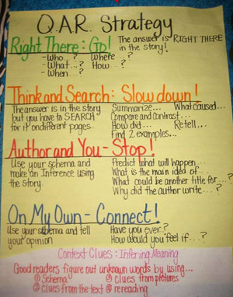Right there – Literal questions whose answers can be found in the text. Often the words used in the question are the same words found in the text.
2. Think and Search Questions – Answers are gathered from several parts of the text and put together to make meaning.
3. Author and You – These questions are based on information provided in the text but the student is required to relate it to their own experience. Although the answer does not lie directly in the text, the student must have read it in order to answer the question.
4. On My Own – These questions do not require the student to have read the passage but he/she must use their background or prior knowledge to answer the question.

* The students read the passage or listen to it read aloud. Have predetermined questions you will ask after you stop reading. When you have finished, read the questions aloud and model how you decide which type of question you have been asked to answer. Work with students on how to find the information in the text to answer the question.

**Sketch to Stretch** – Encourages nonverbal response to provide a framework for interpretive discussion of text.

Students read or listen to the text. The teacher asks students to make quick sketches (realistic or symbolic) of something related to the text that they found interesting, important, etc. The teacher should announce and enforce a 3-minute time limit and remind students that they can make graphs or other symbolic representations rather than pictures. Then small groups assemble. One at a time, group members show their sketches to others. Each student invites others to provide an interpretation of the sketch: “What is this a picture of? What do you think I found important/interesting in the story?” After others give their interpretations, the illustrator in free to comment on the sketch.

**Frayer Model –** Provides for a thorough understanding of new words. Students are asked to provide a definition of the word, facts or characteristics of the word, examples and non-examples. This leads students to a deeper understanding of a word and its relationship to their own lives.



**Summarizing and Note Taking**

**Squares, Triangles, Circles –** Have students list 4 things that “square with my thinking”, 3 “details to support”, and 1 question “circling” in my head.

**Carousel Brainstorming** – On chart paper around the room (or a paper that is passed around groups), ask small groups of students to respond to a question or statement posed at the top of the paper. After a short period of time, student groups move on to another piece of chart paper/topic, and read what has been written about that topic and add to or respond to it. Key reminder – ahead of time prepare the chart paper and the different topics, insuring that you have enough “stations” so that every group is at one station during each rotation.

**Word Splash** – Give students a “splash” of the key words from the lesson. They must write a few meaningful sentences (Summarizing the learning) using these words.

**Reinforcing effort and Providing Recognition**

**Pause, Prompt, Praise –** encourages students to problem solve and self-correct. If a mistake occurs, pause; wait to give the student a chance to solve the problem. Then give a hint or lead to encourage the students. If the answer is not correct after two prompt, give the answer. Use a variety of encouraging words and phrases to support students with their attempts.

**Attitude or Effort Rubric** –

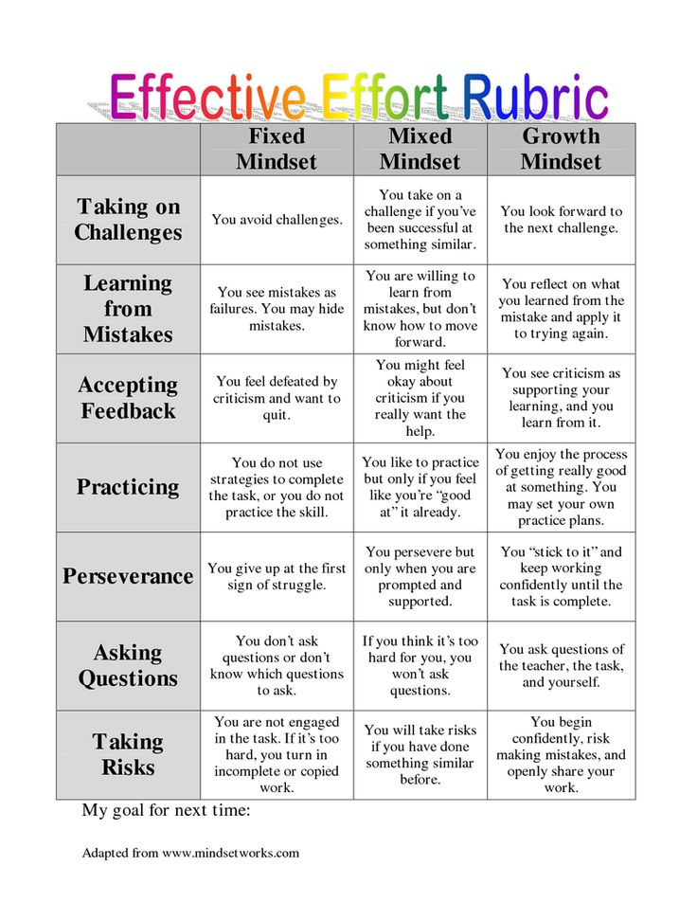

**Homework and Practice**

**Sharing Notebook –** Students write a letter to parents once a week (or whenever the teacher decides) in journal about the work that is happening at school. This can be subject-specific or student’s choice.

**Nonlinguistic Representations**

**Time Sequence Pattern –** Used to organize events in chronological order. It can be used for historical events, but can also be used to tell the events of a story in order.

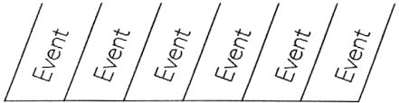

**Concept Pattern Organizer –** Use the organizer to tell the concept being defined, it’s attributes, how it works or what it does, and some examples of the concept.

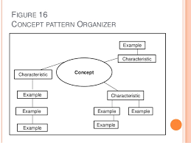

**Cooperative Learning**

**Pass the Pencil –** an interactive approach to engage all students in the writing process. Students are placed into heterogeneous cooperative groups. They pass the paper and pencil around the group and write a response, sentence, thought, etc in order to build their paragraph. Students can assist each other if they do not know the answer or cannot express themselves through writing. Spelling does not count.

**Numbered Heads Together –** Students are placed in groups and each person is given a number (from one to the maximum number in each group). The teacher poses a question and students “put their heads together” to figure out the answer. The teacher calls a specific number to respond as the spokesperson for the group. By having students work together ina group, this strategy ensures that each member knows the answer to problems or questions asked by the teacher. Because no one know which number will be called, all team members must be prepared.

**Generating and Testing Hypotheses**

**Inquiry Charts –** enables students to gather information about a topic from several sources. Teachers design the I-chart around several questions about a topic. Students read or listen to several sources on the topic and record answers to the posed questions within the I-chart. Students generate a summary in the final row. Different answers from various perspectives can be explored as a class.

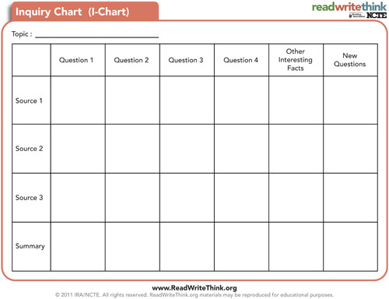

**Stop that Video! -** The idea is that as students watch a video, the teacher will stop playback at key moments in the video to maximize comprehension. During the stoppage, students can reflect on the section that they just viewed, as well as make predictions about what they think could happen next. (Students could also be asked to predict what they expect the video to be about before the film begins). English learners particularly benefit from note-taking sheets that outline key points or questions to be answered in the video. Once students process information independently, they can share and clarify the information with a partner. This strategy allows the teacher to check for understanding throughout the course of the video and address any misconceptions. If a student chooses to process the information with another student in their primary language, their comprehension will most likely be enhanced.

**Questions, Cues, and Advance Organizers**

**Answer-Cite Evidence-Expand/Explain your Answer –** is for demonstrating learning with short answer, extended response items. It helps students show they know or can do the learning standards.

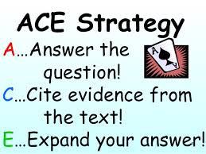

**SQ3R** – (Survey, Question, Read, Recite, and Review) engages students in each step of the reading process including skimming.

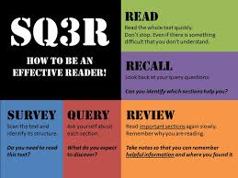

**Development of Academic Vocabulary**

**Word Storm –** visualizes word associations; Starting from a word that you choose, word storms create a map that places related words close together. These word associations can help you find new ideas, inspiration in a brainstorm or getting over a writer’s block. An example of a Word Storm would be a Wordle.

**Word Map**

