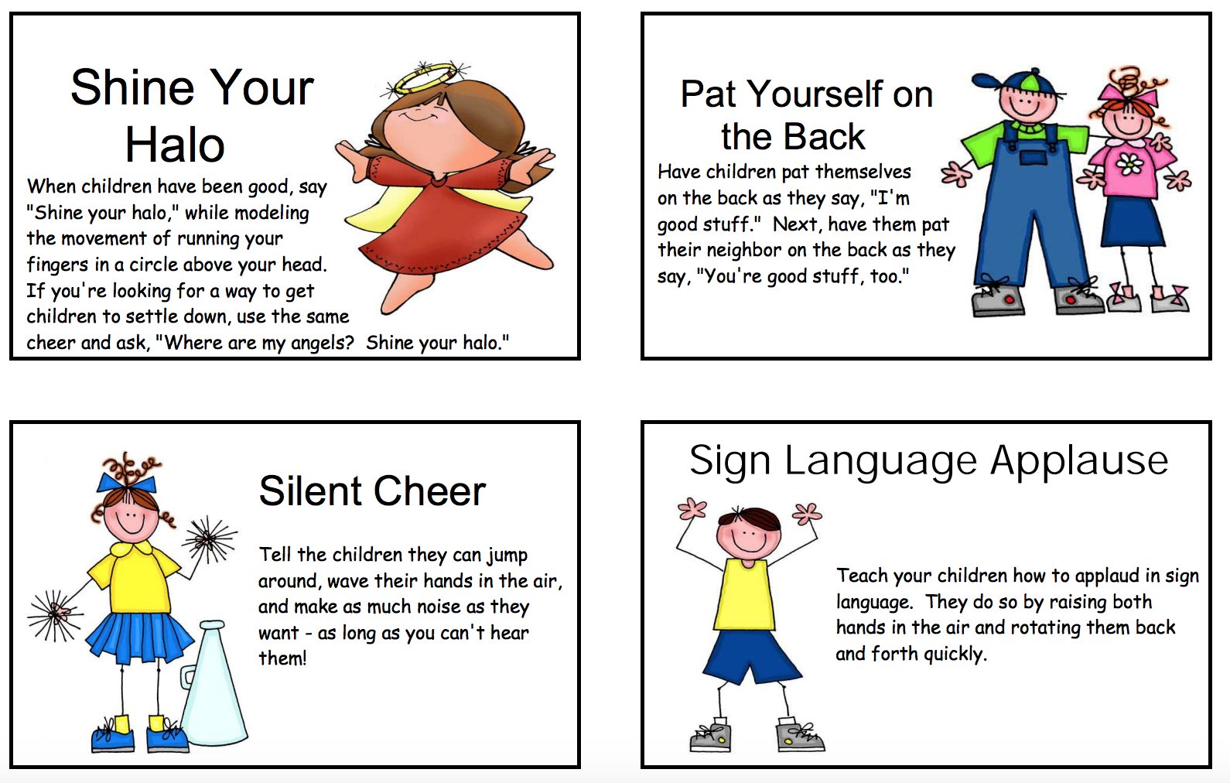

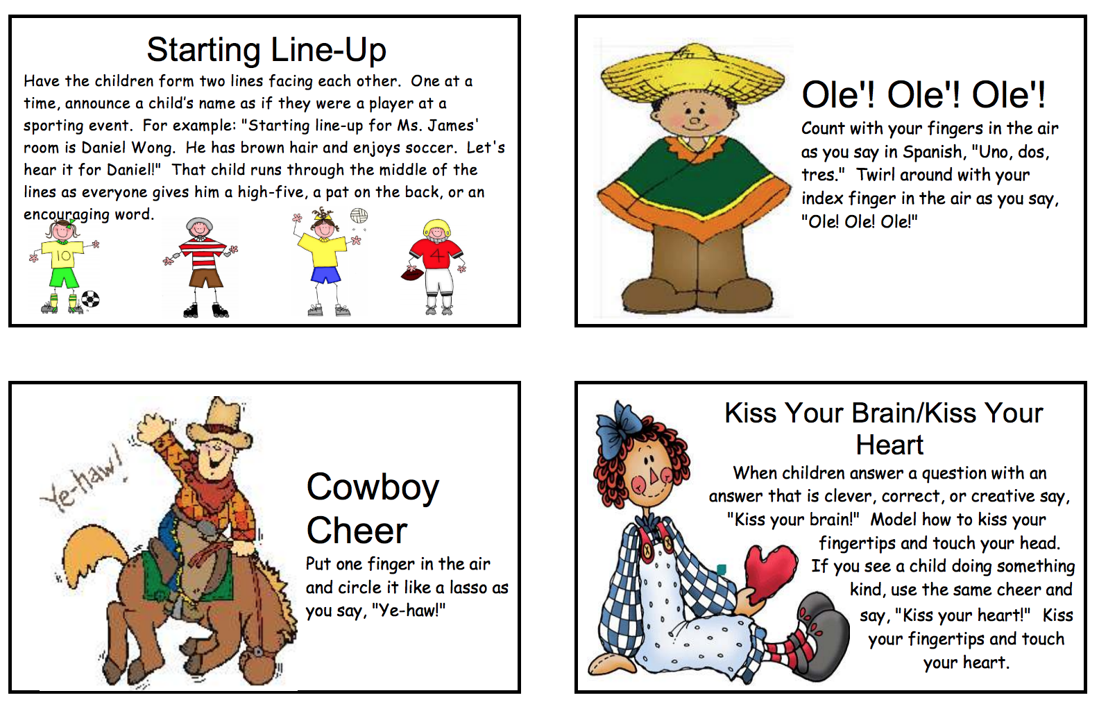

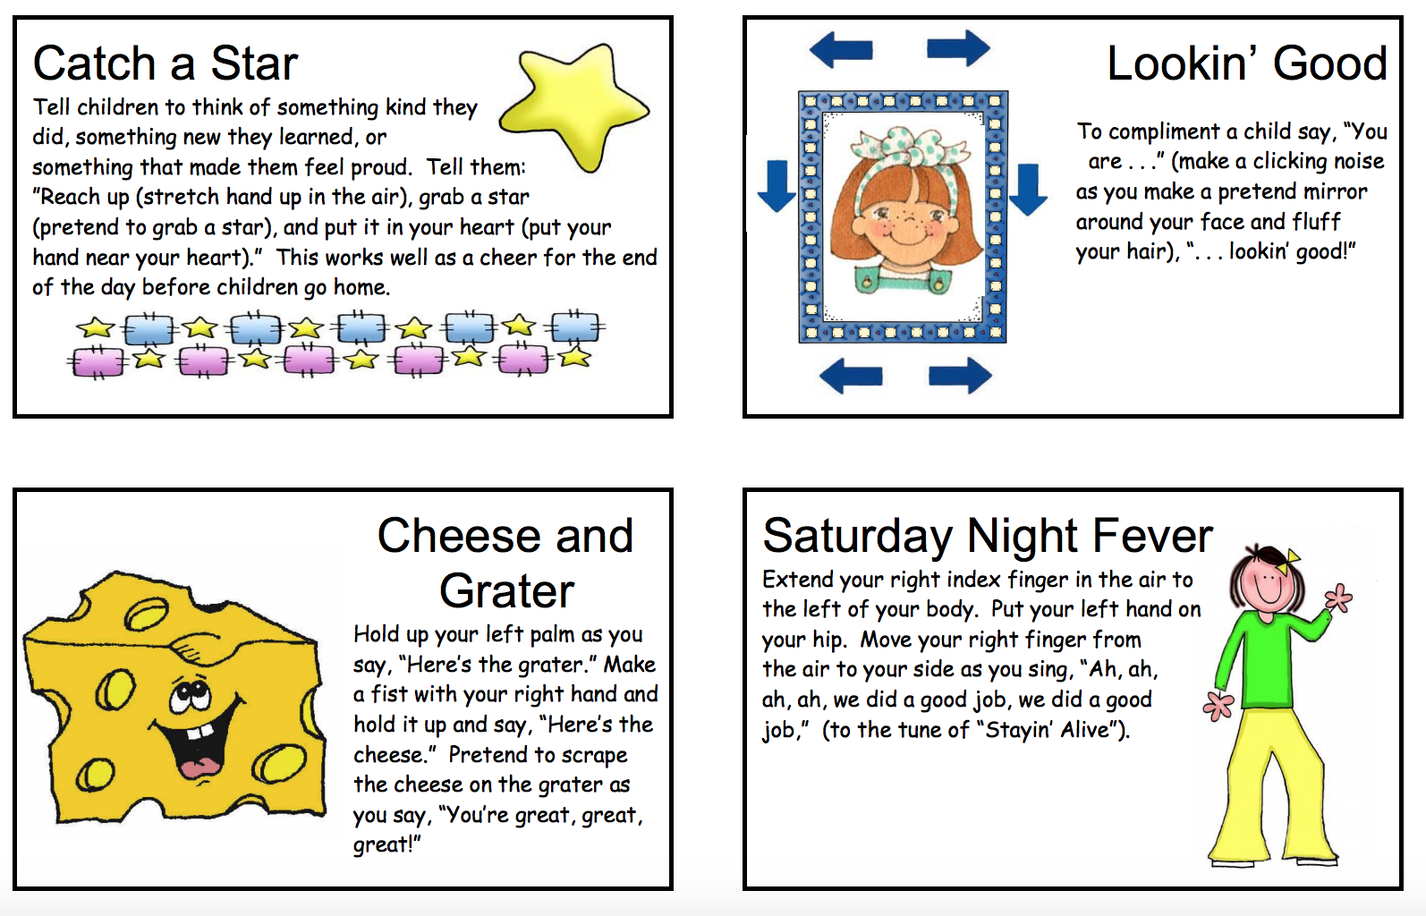

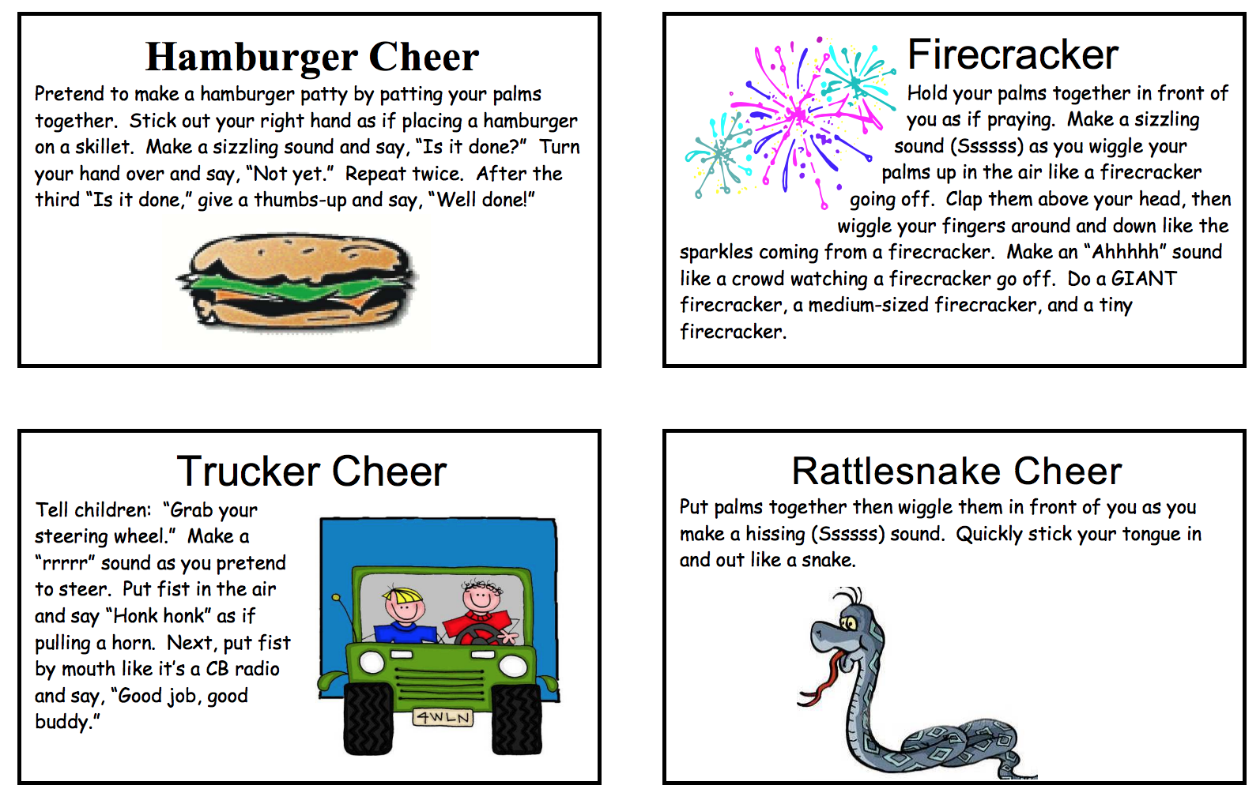

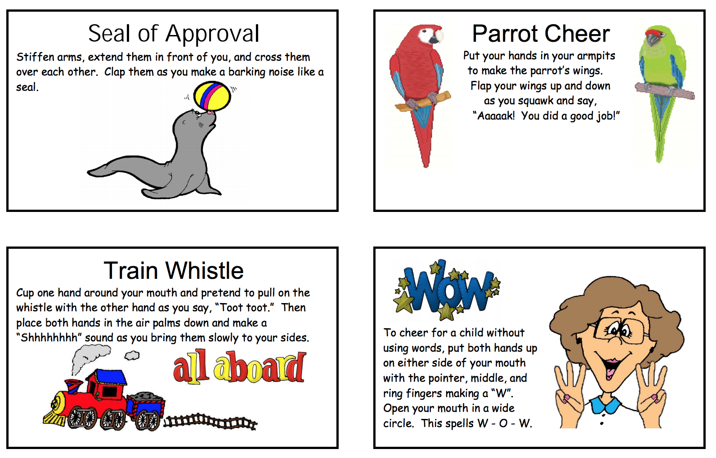

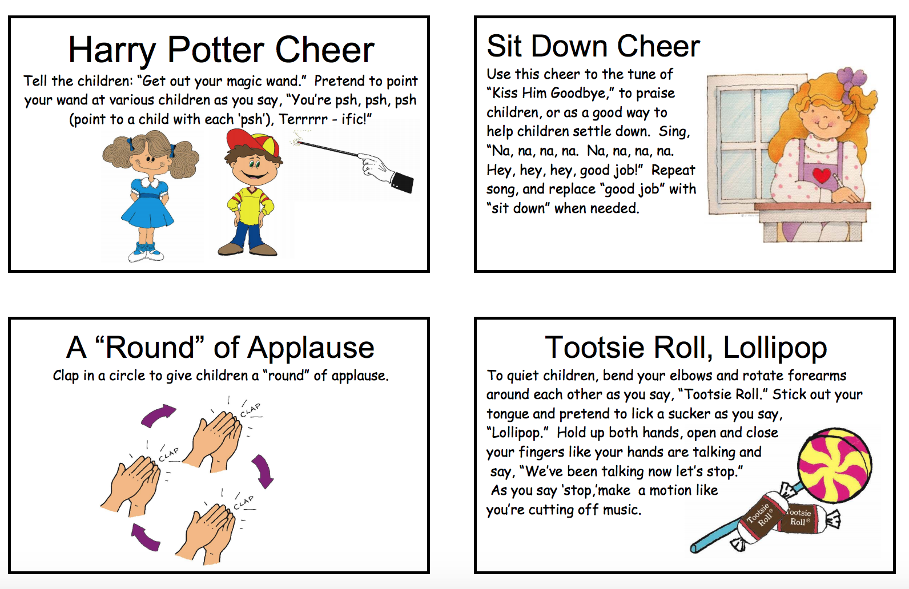

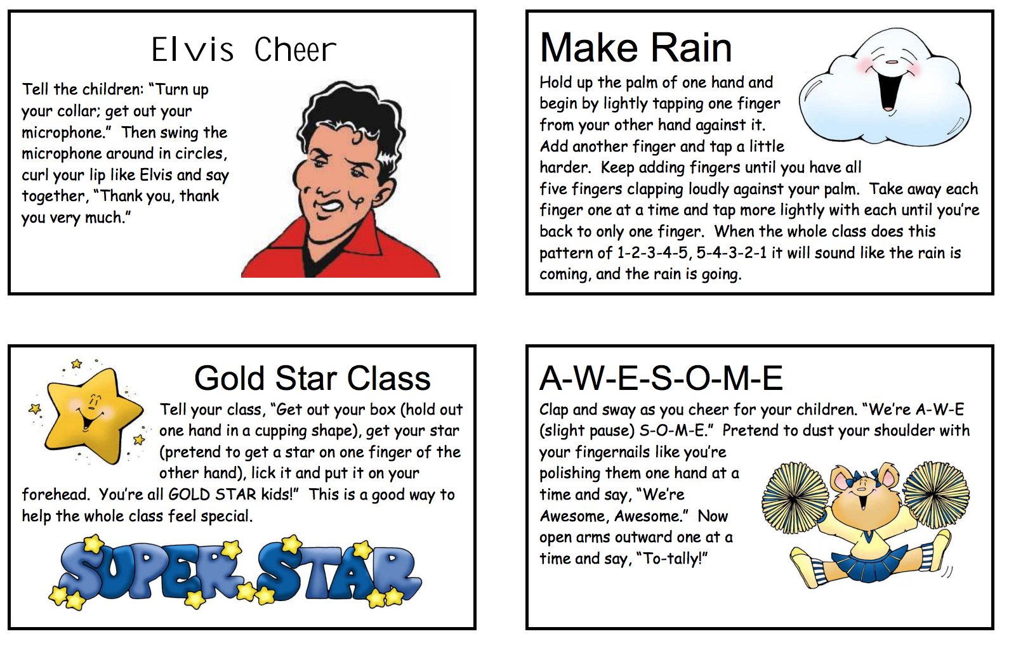

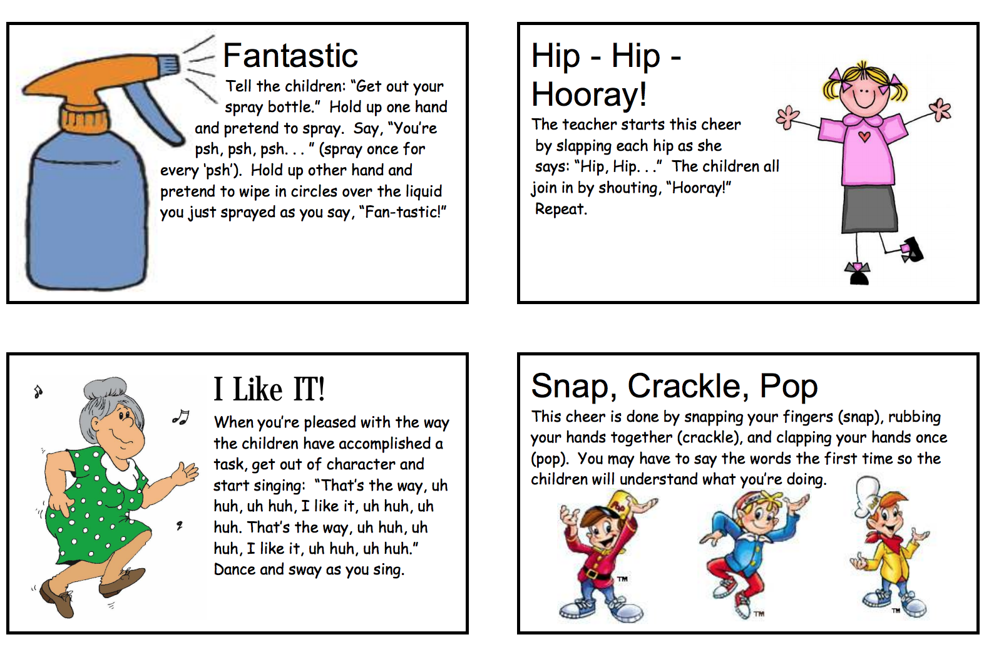

Suggestions for K-12 Classroom Celebrations for Class Goal Achievement,
All Time Best, or Progress Toward Goal Achievement
Criteria:
- Free or inexpensive
- Lasts about three minutes (perhaps longer for achievement of goal)
- Involves everyone in the class in celebrating progress toward, or achievement of, class goal

Progress Towards Goal/ATB: Achievement of Goal:
(Three minutes or less) (May last longer than three minutes)
“Tootie Tah” Bubble Blowing
March to Music Paper Wad Fight
Do “The Wave Relay Race
Class Chant Lunch with a Friend
Paper Airplanes Lunch in the classroom or outside
Riddle Time Bubble Gum Bubble Contest
“Kiss Your Brain” Stupid Human Tricks
Kazoo Salute Run Around the School
Silent Scream Pass the Big Beach Ball
“Fireworks” hand gesture Pick Your Seat for a Day
“Round” of Applause Celebration Bulletin Board display
Announcements on Intercom Class Picture on School Webpage
Singing Hamster (Elvis, Fish, etc.) Announcement on Class Webpage
Class Cheer A few Minutes of Extra Lunch Time
Big Yellow Smiley Face on the Favorite Athletic Team Day
Act section of the PDSA Sport, Sock, Hat, Super Star, Pajama Day
Listen to Music during Work School Spirit Day
One Song Dance Party: 5 Extra Minutes Outside
“Celebrate Good Times” Guest Reader, Speaker or Story Teller
“YMCA” Listen to Music Students Bring
Theme from “Rocky,” Go Outside with another Class/Friend
“We are the Champions” Balloon Lift Off
“You’ve Got the Power” Create a song/rap/skit
“The Chicken Dance” Principal presents certificate to class
“The Hokey Pokey” Kicking balls into the Soccer Goal – “Goal Achieved”
“The Macarena” Shooting Baskets with Basketball – “Goal Achieved”
Earn minutes to save for Choice Time
a larger break or class event Quiet Ball
Extra Recreational Reading Time
Read with a Class or with a Friend
Chat with a Friend/Social Time
Extra Computer Time
One Song Dance Party with the Principal

